Sed Substitution Basics
In this lab, you will learn how to:
- Substitute Text (s): Perform basic find and replace operations.
- Global Replacement (g): Replace all occurrences of a pattern in a line, not just the first one.
- Use Custom Delimiters: Handle text containing slashes (like file paths) using alternative delimiters.
- Edit In-Place with Backups: Modify files safely by creating backup copies automatically.
Basic Substitution
Let's start with a simple substitution on a string. We will change the word "World" to "Linux".
The command for substitution in sed is s.
The syntax is s/Pattern/Replacement/.
This command shape is so common that many users think of sed as a "search and replace tool," but it is really a stream editor. Substitution is simply one of its most frequently used editing commands.
Run this command to see it in action:
Global Replacement
By default, sed only replaces the first match it finds on each line.
If you have the text "apple apple" and substitute "apple" with "orange", sed will output "orange apple".

To replace all occurrences on a line, you must use the Global flag (g) at the end of the substitution command.
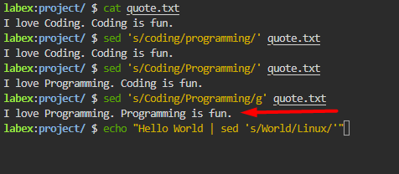

Use Different Delimiters
Standard sed syntax uses forward slashes / as delimiters: s/old/new/.
However, if the text you are replacing contains slashes (like a file path: /usr/local/bin), you would have to escape every slash with a backslash. This makes the command hard to read: s/\/usr\/local\/bin/\/bin/.
Fortunately, sed allows you to use almost any character as a delimiter. Common alternatives are #, :, or |.
Choosing a readable delimiter is a practical skill, not just a syntax trick. When patterns contain many / characters, changing the delimiter makes the command easier to understand and less error-prone.
Create a file containing a path:
Now replace /usr/local/bin with /bin using # as the separator:
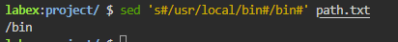
Result: /bin

Because we used # as the delimiter, sed treated the / characters in the path as normal text, making the command much cleaner and easier to read.
In-Place Editing with Backup
So far, sed has only printed the changes to the screen. To modify the file directly ("in-place"), we use the -i option.
However, modifying files directly can be risky. If you make a mistake in your pattern, you might lose data. Ideally, you should create a backup of the original file before modifying it.
You can do this by providing an extension to the -i option, like -i.bak.
Let's modify quote.txt and create a backup named quote.txt.bak automatically.
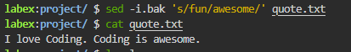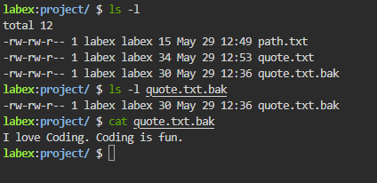
Result: I love Coding. Coding is fun.
This is a best practice when applying batch edits to multiple files.
That backup habit matters because non-interactive edits are fast but unforgiving. When you automate text replacement across files, a small pattern mistake can spread quickly, so keeping the original copy is a simple form of safety.
Summary
In this lab, you learned the essentials of text substitution with sed:

Substitution (s///): The standard command for finding and replacing text.
Global Flag (g): Replacing all instances of a pattern on a line.
Custom Delimiters: Using characters like # to safely handle paths and URLs containing /.
In-Place Backup (-i.bak): Safely modifying files while preserving the original content.
These skills enable you to automate complex text processing tasks efficiently and safely.
sed Stream Editing
Introduction
When working with text files in Linux, you often need to perform automated edits without opening an interactive text editor. For example, you might need to remove a header from a CSV file, delete blank lines, or extract a specific range of lines from a log file.
For these tasks, we use sed (stream editor).
sed is a powerful non-interactive text editor. It reads input from a file or pipe, performs operations on each line, and outputs the result. This "read, transform, print" model is a classic Unix approach and works especially well in pipelines.
That model explains the name stream editor. sed is designed to work on flowing text, not only on files opened like a full-screen editor. This is why it fits so naturally into shell pipelines and automation scripts.
In this lab, you will learn how to:
- Delete Lines (d): Remove unwanted headers or comments.
- Remove Empty Lines: Use regular expressions to filter out blank lines.
- Insert Text (i): Add new lines to the file.
- Print Lines (p): Extract specific ranges of lines.
Delete Lines
Let's start by inspecting our sample file.
cat /home/labex/project/data.csv
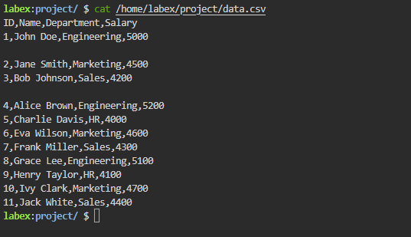
To delete lines in sed, we use the d command.
1d deletes line 1.
1,2d deletes lines 1 through 2.
Addressing lines by number is one of sed's basic ideas. An address tells sed which line or range of lines a command should apply to, and the editing command tells it what to do there.
Run the following command to preview the deletion (without modifying the file):
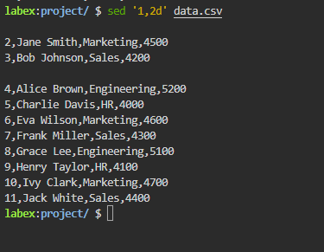
Explain Code
The output shows the file content without the first two lines. However, check the file content again:
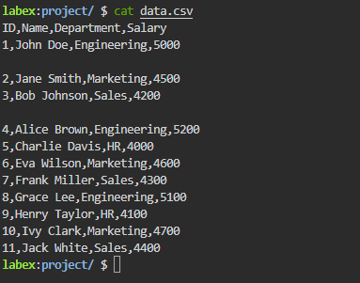
Explain Code
The lines are still there. By default, sed sends output to the screen (standard output) and does not modify the original file. This is a safety feature.
To apply changes to the file (edit "in-place"), use the -i option:
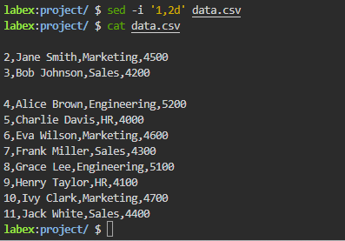
Explain Code
Now the header lines have been permanently removed
Remove Empty Lines
Our file still contains empty blank lines that break the structure of the data. We rarely want these in processed data files.
To remove them, we combine the delete command (d) with a Regular Expression (Regex).
^ matches the start of a line.
$ matches the end of a line.
^$ matches a line that starts and immediately ends, i.e., an empty line.
This is a good example of sed combining two layers: an address pattern and an editing action. The pattern /^$/ selects matching lines, and d deletes those selected lines.
The command /^$/d tells sed to "delete any line that matches the empty pattern".
Run the command to remove empty lines in-place:
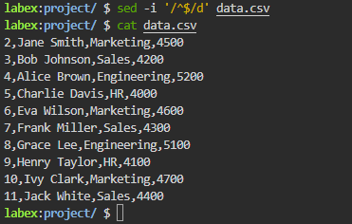
Insert Text
Now that the useless comments are gone, let's say we want to add a proper classification header to the file.
The i (Insert) command adds text before the specified line.
1i Text inserts "Text" before line 1.
The a (Append) command adds text after the specified line.
1a Text inserts "Text" after line 1.
Along with delete and substitute, commands like i and a show that sed is not limited to replacement. It can reshape the stream by removing, adding, and selecting lines as they pass through.
Run the following command to insert "Company Confidential" at the very top of the file:
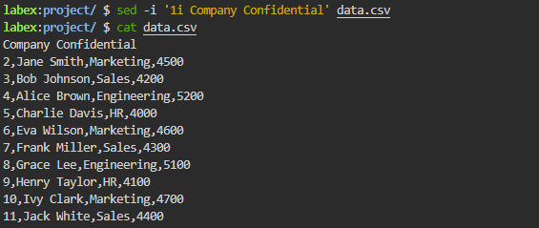

Print Specific Lines
Sometimes you don't want to edit the file; you only want to extract specific lines. sed can act like a smarter version of head or tail.
By default, sed prints every line it processes. To print only specific lines, we:
Use the -n option to suppress automatic printing (be silent).
Use the p command to explicitly print specific lines.
Without -n, sed would print every line automatically and then print the selected lines again when p runs, which often confuses beginners. -n turns off the default behavior so your command prints only what you asked for.
To print lines 5 through 10:
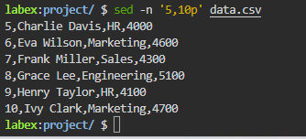
To print only the last line, use the $ symbol to represent the end of the file:
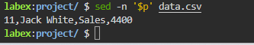
Summary
In this lab, you learned the basics of stream editing with sed:
Deletion (d): Removing specific lines (1,2d) or lines matching a pattern (/^$/d).
Insertion (i): Adding text into the file stream at specific locations.
Printing (-n ... p): suppressing default output and printing only selected lines.
In-Place Editing (-i): Modifying the file directly instead of just printing to the screen.
sed is an essential tool for automated text processing and is widely used in shell scripts for configuration management and log analysis.
AWK Column Extraction
Introduction
When working with structured text data in Linux—such as log files, CSVs, or configuration files—you often need to extract specific columns of information. For instance, you might want to get just the usernames from a system file or the status codes from a web access log.
The primary tool for this task is awk.
awk treats text as a series of records (lines) and fields (columns). This is one reason plain text remains so useful in Linux: many administrative data formats are easy to inspect with your eyes and easy to process with command-line tools.
- Records are usually separated by newlines.
- Fields are usually separated by whitespace (spaces or tabs).
This "records and fields" model is the mental framework that makes awk much easier to understand. Instead of seeing a file as raw text, awk sees structured rows and columns that can be referenced directly.
In this lab, you will learn how to use awk to:
- Select Fields: Extract specific columns using $1, $2, etc.
- Define Field Separators: Handle data separated by characters other than spaces (like colons or commas) using the -F option.
- Reference the Last Field: Dynamically access the end of a line using $NF.

.

